Practical Skills in Agriculture
Testing for the Sugar Content of Food Using the Physics of Light

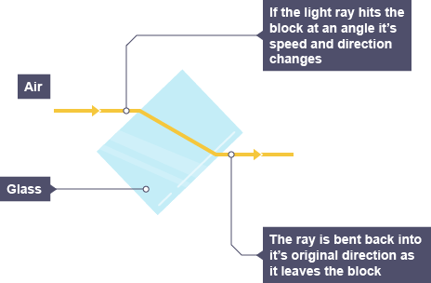
Light is bent every time it comes through the lenses of our eyes; and every time it goes through one substance like water or air, and then goes into another substance like glass or plastic.

The amount of dissolved substances in a solution bends light by different amounts. Sugar is a specific example of this. We can test how much sugar food has in it by seeing how much light can be bent by testing the juice of fruits and vegetables.
Farmers can work out when their fruit is ripe - so they can pick it at just the right time to eat; or make wine from the fruit or preserve it in some way.
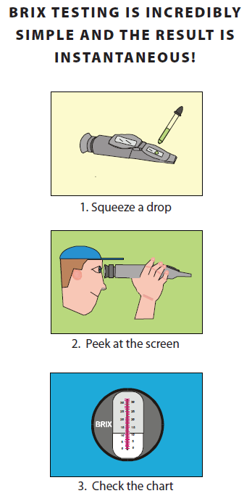
A very common practical skill is to do this testing with a device called a refractometer. Below is a picture of one. The refractometer measures the amount of sugar in what are called Brix units. Higher values mean higher nutrition value.
The procedure for doing the testing is shown on the right.
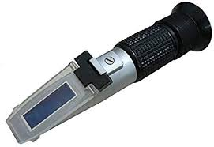

Above is the refractometer similar to the one we will use in class.
Experiment
Today you will measure the sugar content of dissolved substances in different fruits and vegetables. First, you need to calibrate your refractometer by using distilled water. You may have to zero the device by adjusting the top screw, but seek your teacher’s advice if you need to do this.
Next, the fruits and vegetables must be juiced by using either a juice extractor of a simple fork and squashing the fruit. Then a sample of the juice is placed on the refractometer, the flap closed and the measurement taken.
Between each new sample, the delicate refractometer plate must be wiped clean with distilled water (that has no dissolved substances in it).
Record your results below – Get each member of your group to take the reading
Food Item | Brix Reading 1 | Brix Reading 2 | Brix Reading 3 | Average
Dissolved sugar

1. Which of your food has the highest brix measurement? ________________________________
2. Compare your results for at least two food items with typical measurements taken from them
Food 1: __________Your Reading ______________ Poor, Average, Good, Excellent (circle)
Food 2: __________Your Reading ______________ Poor, Average, Good, Excellent (circle)
